Project Plan

<Sydney Airbnb Database Analysis>

Thien Thao My Bui – s5273753

Chelzie Castanares – s5259144

Table of Contents

1.0 Introduction 3

1.1 Problem Background 3

1.2 Scope 3

1.3 Document contents 3

2.0 Work Breakdown Structure 4

3.0 Activity Definition & Estimation 5

4.0 Gantt Chart 6

# Introduction

## Background

Australia has always been known as a safe and stable country that offers a blend of culture, architecture and natural wonders, drawing people’s attention from all over the world. In particular, the largest city in Australia, Sydney, has seen a huge development in the tourism industry over the past few decades. Due to the increasing patterns of migration since the late 1990s, Sydney has attracted multiple travellers worldwide for its unique blend of cultural and linguistic diverse backgrounds within the community. By 2023, it was listed in many trusted reputation rankings and global surveys as one of the best places to live and as a result, earned a reputation for one of the world’s best working and vacation destination.

On the other hand, there are global and national factors associating to such popularity. Besides being acknowledged as a top city for users globally, Sydney has also been ranked as one of the least affordable places due to the increasing cost of groceries, rent and everyday services, specifically the housing market and hotel accomodations. Due to the rise in housing unaffordability within this global city of Australia, Airbnb, a home-sharing platform that was founded in United States in 2008, started to be introduced and entered into Sydney’s tourism industry. Only after a short amount of time, Sydney Airbnb has evolved into a global marketplace for short-term lodging and travel experiences by taking advantage of tourists’ desire for affordable prices and its diversity of lodging options compared to traditional hotel rooms.

## Scope

As a fast-paced and highly innovative sector, the Airbnb business industry must respond to the demands of user expectations and improve their renters’ staying experience. To remain competitive in the tourism sector, this project is associated with InsideAirbnb and their enormous database of all properties for rent. The goal is to implement an interactive software for the clients and will be run and implemented in 12 weeks.

The software would enable users, especially for local and international tourists visiting Sydney, to do some data analysis on the available Airbnb listings across Sydney. Hence, travellers have the ability to plan their vacation with ease and efficiency by finding a suitable place that satisfys their demands in five different ways:

* For a user-selected period, report the information of all listings in a specified suburb.
* For a user-selected period, produce a chart to show the distribution of prices of properties.
* For a user-selected period, retrieve all records that contain a keyword (user entered), e.g. pool, pet.
* Analysing how many customers commented on factors related to cleanliness (multiple key words may be associated with cleanliness – justify your selection).
* Return the average review score and variations of a user-selected property.

## Document contents

To carry out the project efficiently within a short amount of development times and monitor the progress thoroughly, two main sections including a Work Breakdown Structure and Details of activities involved will be provided as below:

* Work Breakdown Structure: different phases and activities involved and completing the project, from initiating and preparatory work to implementation, testing and reporting activites.
* Activitities Definition and Estimate: explanation in details of required activites and their relevant time estimates and scheduling to process and complete.

# Work Breakdown Structure

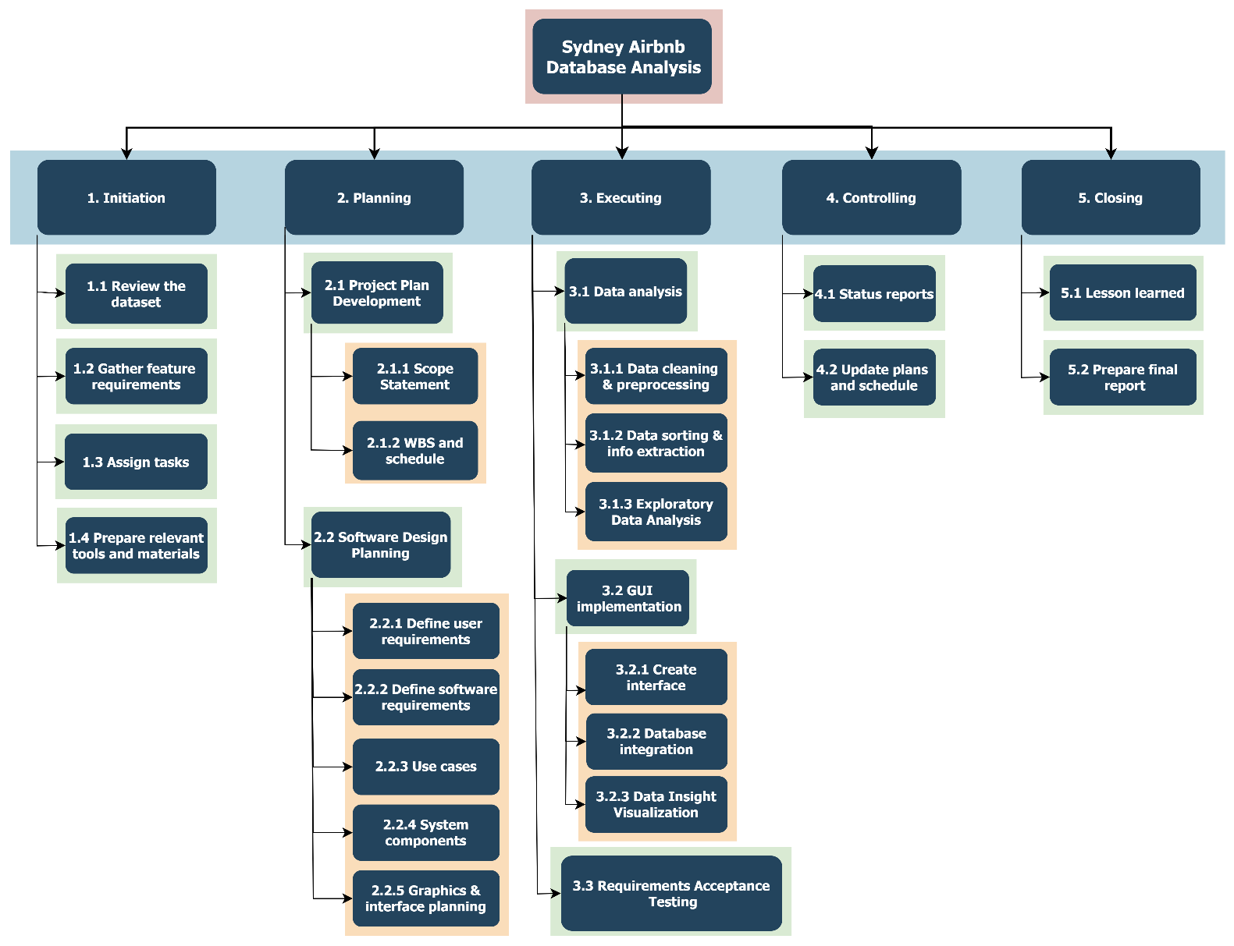

# Activity Definition & Estimation

|  |  |  |  |
| --- | --- | --- | --- |
| # | **Activity** | **Defintion** | **Time estimate** |
| 1. **Initiation** | | | |
| 1.1 | Review the dataset | * Looking through all the features and variables in the dataset. * Understanding the structure, meaning and relationships between different tables. | 5 |
| 1.2 | Gather feature requirements | Finding out key information that can provide valuable insights. | 10 |
| 1.3 | Assign tasks | Setting goals and defining roles and responsibilities among team members. | 4 |
| 1.4 | Prepare relevant tools and materials | * Setting up the GitHub repository. * Ensuring everyone has access to essential documents and resources. | 7 |
| 1. **Planning** | | | |
| 2.1 | Project Plan Development | Making a guidance on how the project will be processed and controlled. |  |
| 2.1.1 | *Scope Statement* | Based on insights found, specifying the primary goals and listing out the project’s objectives, deliverables and constraints. | 7 |
| 2.1.2 | *WBS and schedule* | * Setting up meeting schedule for an efficient communication among the team members. * Breaking down the project’s structure into milestones, smaller components and tasks in each section. * Outline how project progress will be implemented and completed step by step with target deadline. | 7 |
| 2.2 | Software Design Planning | Deciding and defining how the data analyse system will be built and function effectively for the users. |  |
| 2.2.1 | *Define user requirements* | Specifying:   * How the users are supposed to interact with or use the program. * What can users achieve with the system. | 6 |
| 2.2.2 | *Define software requirements* | Specifying:   * What the requirements are for the software. * What functionality the software will provide. * The performance of the software. | 5 |
| 2.2.3 | *Use cases* | Providing instruction on how people would use the software depends on different features the software can provide. | 6 |
| 2.2.4 | *System components* | Identifying main functions, data structures and algorithms the software would use to load the user’s inputs, analyse and display relevant data information. | 11 |
| 2.2.5 | *Graphics and interface planning* | Designing the structure of the interface including screens, menus, options and how do they interact with the users, what function would they provide. | 10 |
| 1. **Executing** | | | |
| 3.1 | Data analysis | Specifying the process of transforming the dataset to interpret and discover essential information for the project objectives. |  |
| 3.1.1 | *Data cleansing and preprocessing* | * Clearly identifying necessary variables that needed to be included. * Excluding irrelevant columns and rows that may not contribute to the analysis. * Detecting null values and handle missing data appropriately). | 5 |
| 3.1.2 | *Data sorting and info extraction* | * Extracting the data characteristics such as statistics table, patterns and trend. * Standardizing the data input and variable formats homogeneously between different variables. | 3 |
| 3.1.3 | *Exploratory Data Analysis* | Based on the project scopes and objectives, carry out a summary of the dataset with relevant features and visualize them effectively through suitable charts, plots, and tables for better understanding for the users. | 6 |
| 3.2 | GUI implementation | Building a platform for the software application with interactive elements to enhance the user experience. |  |
| 3.2.1 | *Create interface* | Based on the design plan, implementing the layout and appearance of the interface with visual assets: images, icons, buttons, menu bar, content areas, filter bars..etc. | 10 |
| 3.2.2 | *Database integration* | Connecting the GUI to the database with common database operations (loading, inserting, updating, deleting and querying data). | 6 |
| 3.2.3 | *Data Insight Visualization* | * Choosing the appropriate types of visualization widgets and customize the appeareance to align with the application’s design (colors, fonts, legends, labels) * Implementing interactive features that allow users to manipulate and explore data point between different views. | 5 |
| 3.3 | Requirements Acceptance Testing | * Identifying detailed test scenarios based on the requirement features, including the input actions and both expected and actual outcomes. * Evaluate the test cases whether they meet the acceptance criteria. | 11 |
| 1. **Controlling** | | | |
| 4.1 | Status reports | * Keeping up with the project’s progress by reporting the duration and percentage complete. * Identifying any issue or technical problem to specify immediate action. | 60 |
| 4.2 | Update plan and schedule | Adjusting the project’s tasks and timeline according to any changes in the time estimate, scope or deviations from the original project planning document. | 18 |
| 1. **Closing** | | | |
| 5.1 | Lesson learned | * Reflecting the project’s successes, constraints and challenges. * Identifying areas for improvement and suggest some. recommendations and strategies for future projects. | 3 |
| 5.2 | Prepare final report | * Reviewing if all the project documents are up-to-date and teammates have completed every tasks. * Finalizing the project by writing an executive summary of the project’s progress with its achievements and deliverables. | 9 |

# Gantt Chart

